5G Academy
Fastweb + Vodafone Student Project Program
Gate Evaluation Report Template
Group Number | 4
Group Leader | Fauzan Ejaz
Group Members | Fauzan Ejaz (Leader), Adithya Zacharia Valavi, Ghazanfar Anees Siddiqui, Llagami Tedi
Project Title | AEGIS - Zero-Trust Identity for AI Agents on the Network
Gate | ☑ Gate 1 ☑ Gate 2 ☑ Gate 3
Submission Date | 14 October 2026

General Instructions
This document serves as the common template for the three progressive Gate evaluations required for each group's Proof of Concept (PoC) project. Each Gate corresponds to a distinct phase of the project and must be completed and submitted according to the schedule provided by the 5G Academy.
Please complete only the relevant section for the Gate you are submitting, keeping the cover page information updated each time.

GATE 1 - Technologies, Planning & Feasibility
This Gate report should cover the technologies involved, the project schedule, the feasibility of the proposed idea, and, where possible, an economic/business analysis.

1.1 Technologies
Describe the key technologies relevant to your project (e.g. 5G features, network functions, devices, protocols, tools):
AEGIS applies a Zero-Trust security model to the identities of the AI agents and automations that operate the 5G control plane. It combines a telecom control-plane surface, a zero-trust security paradigm, and behavioural machine learning:
5G control-plane surface - the 5G Service-Based Architecture (SBA) and Service-Based Interface (SBI): Network Functions (AMF, SMF, NRF, PCF, UDM, NEF) exposing HTTP/2 REST APIs - the same interfaces that orchestration, OSS and closed-loop-automation agents call.
Zero-Trust security (NIST SP 800-207) - continuous, per-request verification of machine identities (“never trust, always verify”), applied to behaviour rather than to credentials alone.
Behavioural fingerprinting & anomaly detection - unsupervised machine learning (Isolation Forest) trained only on legitimate traffic, combined with deterministic policy rules and a session-level state machine that validates PDU-session call sequences.
Detection features - request rate and inter-arrival timing, distinct Network Functions / endpoints, method mix, call-sequence integrity, error rate, payload size, and time-of-day.
Data & tooling - a synthetic 5G SBA traffic generator (Python) produces labelled data with injected attacks; scikit-learn and pandas for modelling; a Streamlit dashboard implements the zero-trust gate (PASS / STEP-UP / BLOCK). Real M2M / API-gateway logs can be ingested if provided.
Deployment vision - in production the gate runs as an inline policy check at the network edge (FASTedge); the PoC runs offline on replayed logs.
Standards & frameworks - NIST SP 800-207, 3GPP SBA, TM Forum closed-loop automation (OODA); aligned with NIS2, GDPR and the EU AI Act.

1.2 Project Schedule (Gantt Chart)
Insert or attach the Gantt chart showing project milestones, tasks, and timeline:
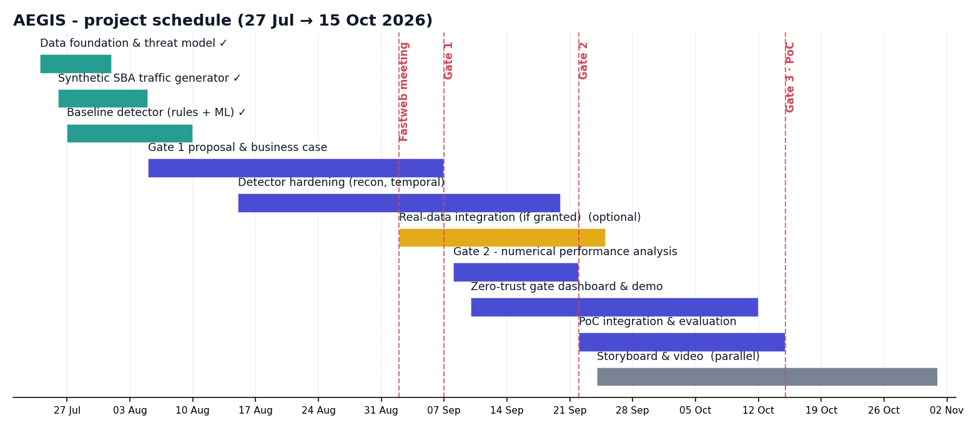
Briefly summarize the main phases and key deadlines:
- Phase 1 - Foundation & baseline PoC (threat model, synthetic 5G SBA data, rules + ML detector) - Deadline: 10 Aug 2026 (completed).
- Phase 2 - Technical solution & evaluation (feature hardening, numerical performance analysis, gate dashboard, optional real-data integration) - Deadline: Gate 2, 22 Sep 2026.
- Phase 3 - Final Proof of Concept & video (integration, live zero-trust gate demo, storyboard & shooting) - Deadline: Gate 3, 15 Oct 2026.

1.3 Feasibility Analysis
Discuss the technical feasibility of the proposed solution (resources, constraints, risks):
The solution is technically feasible and already de-risked by a working baseline prototype:
Resources - entirely open-source (Python, scikit-learn, Streamlit); no specialised hardware, it runs on a standard laptop. Production adds only lightweight edge compute at FASTedge.
Data availability - the main external risk (access to real network traffic) is fully mitigated: the PoC is synthetic-first. A 3GPP-grounded generator produces realistic, labelled SBA traffic; real logs are an upgrade, not a dependency.
Evidence of feasibility - the working baseline already detects all seven modelled threat classes on 11,343 held-out request windows, at ROC-AUC 0.99, 98% recall and a 0.8% false-positive rate.
Key risks and mitigations:
Risk | Mitigation
Synthetic data may not capture real agent behaviour | Modelled on 3GPP SBA semantics; the pipeline ingests real logs when available.
False positives disrupt operations | Held-out calibration + a soft STEP-UP action before BLOCK; thresholds are tunable.
Real-data access is not granted | The full PoC is deliverable on synthetic data alone.
Adaptive / evasive attackers | Layered rules + ML + session state machine; roadmap for periodic retraining.

1.4 Economic / Business Analysis (where applicable)
Provide an estimate of costs, potential business value, and/or market relevance, if applicable to your project:
Illustrative value model, to be validated jointly with Fastweb + Vodafone:
Cost - development is engineering time only (open-source, existing compute, no licensing). Production cost is modest edge compute for the inline gate.
Risk avoided - detecting a compromised or spoofed automation before it acts on the control plane cuts mean-time-to-detect from hours to seconds and contains blast-radius, avoiding outage and breach costs.
Enabler of safe automation - zero-trust on machine identities is the guardrail that lets the operator safely expand network automation (closed-loop / self-healing), protecting the value of the wider AI-native roadmap.
Compliance & audit - supports a NIS2 zero-trust posture; explainable, logged decisions provide audit evidence for GDPR and the EU AI Act.
Operational efficiency - automates machine-identity monitoring that cannot be performed manually at API scale.
Market relevance - securing AI agents on critical infrastructure is an emerging, board-level priority; AEGIS targets a gap that credential-based AAA does not cover.
GATE 2 - Technical Solution & Architecture
This Gate report should cover the proposed technical solution, with a clearly defined architecture and implementation strategy, a complete numerical performance analysis, and a clear description of the expected Proof of Concept (PoC).

2.1 Proposed Technical Solution
Describe the overall solution you propose to address the project's objective:
As AI agents, orchestration bots, and closed-loop automations increasingly issue commands directly to 5G network control services, classical authentication is no longer sufficient to establish trust. A stolen token, a leaked client certificate, or a compromised automation account will still pass authentication - the credential is valid - even though the actor behind it is not the legitimate agent. Classic AAA answers “is the credential valid?” It cannot answer “is this really the agent we onboarded, behaving the way it always behaves?”
AEGIS answers that second question. It is a zero-trust gate for machine identities: it builds a behavioural fingerprint of each legitimate agent from how it actually calls the network's APIs, and continuously scores every new request against that fingerprint, aligned with NIST SP 800-207 zero-trust principles (never trust, always verify; verify continuously; assume breach).
One-line pitch: credentials prove what you have; AEGIS verifies how you behave.
Scope. AEGIS targets service/automation agents (orchestration, closed-loop automation, OSS/BSS jobs, API clients) calling network control APIs, modelled on the 5G Service-Based Architecture (SBA) / Service-Based Interface (SBI): AMF, SMF, NRF, NEF, PCF, UDM. End-user devices, the data plane, and general “AI safety” are explicitly out of scope: AEGIS guards the control-plane API surface used by machine actors, which keeps the problem concrete and solvable within the PoC timeline rather than open-ended.
The solution in one pipeline: OBSERVE request patterns and metadata (id, timing, call sequence, payload shape) -> FINGERPRINT a known-good behavioural baseline per agent -> SCORE with rules plus an ML anomaly/spoof score -> DECIDE PASS / STEP-UP / BLOCK (zero-trust gate dashboard).
Threats the solution is built to catch. We assume an attacker who has already obtained a valid credential (the realistic case) or controls a legitimate agent, and must therefore be caught by behaviour, not by credential checks:
# | Threat | Behavioural signal AEGIS keys on
T1 | Identity spoofing / impersonation | Fingerprint mismatch: wrong endpoint mix, timing, sequence for that identity
T2 | Compromised agent | Drift from its own baseline: new endpoints, new methods, elevated error rate
T3 | Reconnaissance / enumeration | High cardinality of endpoints/targets, many 403/404s, breadth over depth
T4 | Volumetric abuse / DoS | Request-rate spike far above the agent's normal envelope
T5 | Low-and-slow exfiltration | Abnormal read/GET ratio and payload sizes, off-hours persistence
T6 | Replay / sequence anomaly | Broken call-sequence pattern vs the agent's normal call graph
T7 | Privilege / scope creep | Calls to NFs never in the agent's baseline scope

The gap, the solution, and the state of the art, in one place. The gap: a credential check proves you have the right token, once, at the door - it never asks whether the traffic behind that token still behaves like the agent it claims to be, so a stolen or misused identity passes every time. Our solution: a behavioural fingerprint per agent, scored continuously through the observe / fingerprint / score / decide pipeline above. Against the state of the art: a named, reimplemented Statistical Process Control baseline scores 0.929 ROC-AUC / 64.0% recall on our own data; AEGIS scores 0.979 / 91.6% - a statistically significant gap (p = 0.015), not an assumed one. Full comparison in section 2.4.
This directly extends the Gate 1 feasibility case: the technology (behavioural fingerprinting and anomaly detection), the risks, and the economic rationale (enabling safe automation, NIS2/GDPR/EU-AI-Act audit evidence) were validated at Gate 1. Gate 2 delivers the concrete architecture (2.2, with a full system diagram), a working implementation (2.3), and numerical proof that the approach works (2.4), the three things Gate 1 could only describe as intent.

2.2 Architecture
Provide a clear diagram and description of the system architecture:
AEGIS is structured as a four-stage pipeline sitting logically in front of the network's control-plane APIs. Every request an agent sends to a Network Function is observed by the gate before (in production) or in parallel with (in the PoC) reaching the NF. See Figure 2.1.
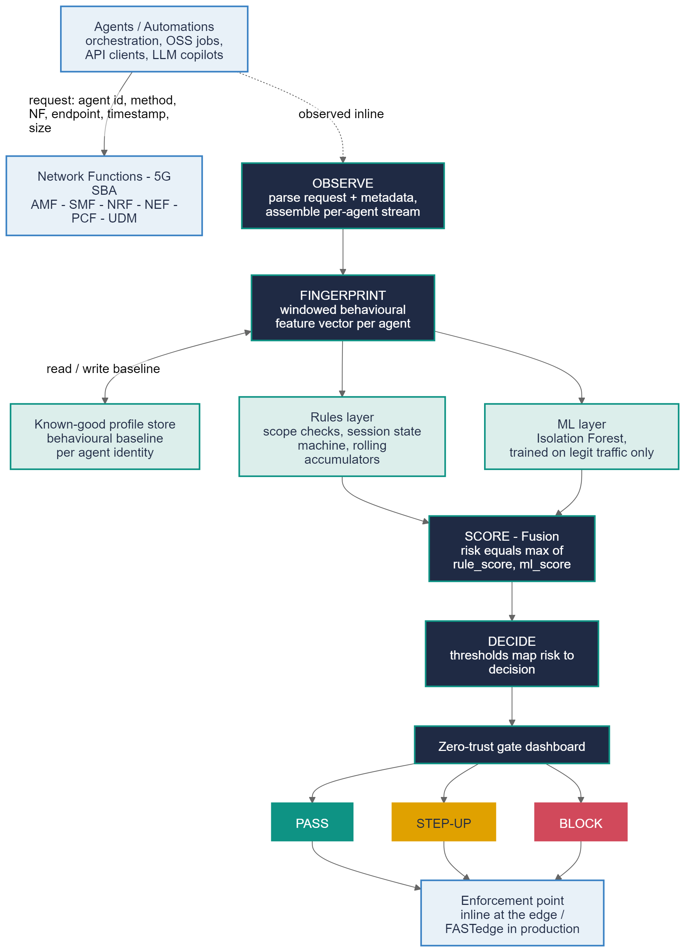
Figure 2.1 - AEGIS system architecture: OBSERVE -> FINGERPRINT -> SCORE -> DECIDE, with the rules layer, ML layer, and known-good profile store feeding SCORE, and PASS / STEP-UP / BLOCK as the three decision outcomes.
Component description:
OBSERVE. Every request is parsed into a normalized event: agent identity, HTTP method, target Network Function, endpoint, timestamp, and payload size. Events are grouped into a per-agent stream, the unit the rest of the pipeline operates on.
FINGERPRINT. Requests are aggregated into sliding 60-second windows and turned into a feature vector per agent, per window: volume/rate, surface (distinct NFs/endpoints/target IDs), method mix, sequence, errors, payload, temporal (hour-of-day), and cross-window breadth (a rolling union of endpoints/NFs and error count over the trailing 5 minutes, so reconnaissance spread thin enough to look quiet in any single window is still caught). These vectors are compared against a known-good profile store, the behavioural baseline built for each agent during onboarding.
SCORE. Two layers run in parallel and are fused. The rules layer (fast, explainable) applies hard caps and forbidden transitions, a session-state machine that tracks PDU-session lifecycle (catching orphaned update/release calls, T6), and rolling 5-minute accumulators (breadth, error count, peak payload) that catch cumulative anomalies too sparse for any single window (the mechanism behind T3 and T5 detection). The ML layer is an Isolation Forest trained only on legitimate traffic, engaging once an agent has at least 10 requests in the trailing 5 minutes. Fusion: risk equals the maximum of the rule score and the ML score. Thresholds are tuned for a realistic false-positive budget (about 1.5 %) rather than maximum sensitivity, which is why detection is intentionally not uniform across threats (see 2.4).
DECIDE. The fused risk score maps to PASS (low risk, behaves like its known-good self), STEP-UP (medium risk: re-authentication, approval, or throttling), or BLOCK (high risk: quarantine the identity, alert the SOC).
Trust boundary. Every request from an agent to a Network Function crosses the AEGIS gate. In production this is envisioned as an inline policy check at the edge (FASTedge); for the PoC it runs as an offline/log-replay analysis over synthetic SBI-style traffic.
Dashboard / enforcement surface. A Streamlit application exposes, per agent, current risk, PASS/STEP-UP/BLOCK status, a breakdown of detections by threat type, and an incident inspector with a plain-language explanation of why a request was flagged.

2.3 Implementation Strategy
Describe how the solution will be implemented step by step (tools, platforms, methodology):
Methodology. AEGIS is built bottom-up, PoC-first, and evaluation-driven: the ML/security equivalent of test-driven development. No rule or model change is kept unless it is immediately re-scored against the full labelled dataset and shown to improve (or at least not regress) the numbers in 2.4. Each of the four architectural stages is a separately runnable, separately verifiable script.
Tools and platforms:
Layer | Tool / platform | Role
Language/runtime | Python 3.12 | Single language across generation, detection, and dashboard
Data generation & processing | pandas, NumPy | Synthetic SBI-traffic generation, windowing, feature engineering
Anomaly detection | scikit-learn (Isolation Forest) | Unsupervised ML layer, trained on legitimate traffic only
Visualization / gate UI | Streamlit, Matplotlib | Live zero-trust gate dashboard and evaluation charts
Deck/report tooling | python-docx, python-pptx | Reproducible generation of the Gate decks and reports
Delivery | Git/GitHub, GitHub Pages | Version control and a public showcase site

Implementation phases:
Phase | Output | Primary file(s)
1. Synthetic environment | Labelled SBI-style traffic, 5 agents, T1-T7 | generate_synthetic_traffic.py
2. Fingerprinting | Per-agent windowed feature vectors | aegis_detect.py (build_windows)
3. Rules layer | Deterministic scope/session/rolling checks | aegis_detect.py (rule_score)
4. ML layer | Isolation Forest fit on legit-only traffic | aegis_detect.py (ml_scores)
5. Fusion & decision | Risk scoring, PASS/STEP-UP/BLOCK | aegis_detect.py (main, decision)
6. Dashboard | Live zero-trust gate UI | aegis_dashboard.py
7. Evaluation & iteration | Metrics, charts, bug-fixing loop | aegis_baseline_metrics.md

Step-by-step, and what the evaluation loop caught:
Synthetic traffic generation produced 210,000 requests across 5 legitimate agent profiles with realistic PDU-session lifecycles, plus the seven threat scenarios injected as labelled anomalous segments, removing the dependency on real operator logs.
Feature engineering turned the windowed request stream into the behavioural feature vectors described in 2.2.
The rules layer implements deterministic scope, rate, and session-sequence checks. An earlier T6 window-count heuristic was replaced with a session-ID state machine after it was found to false-fire on legitimate bursty traffic.
The ML layer, an Isolation Forest, is fit only on legitimate traffic with a held-out calibration split.
Fusion and decision policy combine rule and ML scores into PASS / STEP-UP / BLOCK.
The dashboard exposes per-agent risk, decisions, per-threat breakdown, and the incident inspector.
Evaluation and iteration: re-scoring after every change surfaced two real bugs, not just tuning cosmetics. First, T3 and T5 are naturally sparse per window; rolling 5-minute accumulators fixed this generically. Second, the initial T2 and T5 attack scenarios both had the injected agent call a Network Function outside its own onboarded scope, indistinguishable from T7 to the rules layer, so both were trivially caught by the scope rule rather than the drift/payload logic they were meant to test. Redesigning both to stay within the attacking agent's own scope forced detection to rely on the intended statistical signal, which is the origin of the non-uniform per-threat numbers in 2.4.

2.4 Numerical Performance Analysis
Provide quantitative results, simulations, calculations, or expected performance metrics supporting your solution:
Benchmarking against real-world detection systems, not just internal targets. Before finalizing the operating point, we researched how comparable systems perform in practice, since a PoC that reports 100 percent detection on everything is a red flag to anyone who has looked at production security data, not a strength.
Published NIDS studies on CICIDS2017/UNSW-NB15 consistently show volumetric/DoS attacks detected at 97 to 99.8 percent (large, unambiguous signal), while reconnaissance and other low-frequency attack classes detect far lower unless heavy class-balancing is applied.Industry SOC data (Microsoft/Omdia State of the SOC 2025, SANS 2025 Detection and Response Survey) puts typical false-positive rates at 46 to 83 percent, with elite, well-tuned SOCs under 10 percent, and under 5 percent considered excellent.
UEBA/insider-threat research shows a hard precision/recall: models reporting near-perfect recall do so by sacrificing precision, sometimes to as low as 0.54; low-and-slow exfiltration is consistently the hardest category.
We therefore tuned AEGIS's decision thresholds and rule sensitivities for a realistic false-positive budget (about 1.5 percent), in the well-tuned-not-superhuman range, rather than for maximum sensitivity, and treated a non-uniform, threat-dependent detection rate as the expected, correct outcome rather than something to eliminate.
Test set: 15,363 held-out windows (14,946 legitimate, 417 attack), 60-second window size, decision thresholds STEP-UP at 0.6 or above and BLOCK at 0.85 or above.
Headline metrics (rules + ML fused):
Metric | Value
ROC-AUC | 0.979
Precision | 0.640
Recall (detection rate) | 0.916
F1 score | 0.753
False-positive rate (legit traffic flagged) | 1.44%
ROC-AUC, ML only (no rules) | 0.717

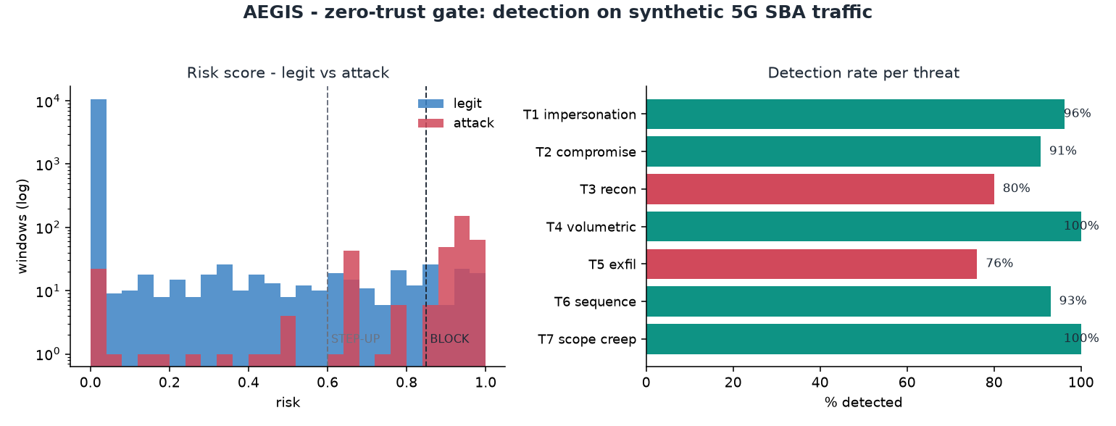
Figure 2.2 - Risk-score separation between legitimate and attack windows (left) and detection rate per threat (right).

Detection rate per threat type, deliberately not uniform:
Threat | Windows | Detected | Why this level
T1 - Identity spoofing / impersonation | 58 | 100% | Scope or identity mismatch against the agent's own baseline, including the harder broad-scope variant
T4 - Volumetric abuse / DoS | 90 | 100% | Loud rate spike, the easiest signal in the literature, including the slow-ramp variant caught by the rolling accumulator
T7 - Privilege / scope creep | 70 | 100% | Deterministic policy/ACL check, not statistical inference, including the alternate agent/NF pairing variant
T3 - Reconnaissance / enumeration | 58 | 95% | Enumeration within an agent's own scope, hardest class in NIDS benchmarks
T2 - Compromised agent | 44 | 84% | Drift confined to the agent's own scope, relies on genuine behavioural drift
T6 - Replay / sequence anomaly | 58 | 76% | An isolated single anomaly without context is treated as ambiguous
T5 - Low-and-slow exfiltration | 39 | 72% | Hardest threat category industry-wide, caught only via rolling accumulation

Two of these threats (T4, T7) are legitimately near 100 percent because they are not statistical detection problems, a rate cap and a scope/ACL check are deterministic lookups. The other five sit in a genuine 76 to 96 percent spread that tracks the strength of their underlying behavioural signal: loud beats subtle, and diffuse/low-and-slow attacks are always the hardest.
Gate decisions on the test set:
Decision | Windows | Share
PASS | 14,766 | 96.1%
STEP-UP | 166 | 1.1%
BLOCK | 431 | 2.8%

Interpretation:
A 1.44 percent false-positive rate sits inside the well-tuned-SOC band from the industry data above, without claiming an implausible near-zero rate.
91.6 percent recall means roughly 9 in 10 attacks are caught before reaching PASS, strong but honestly short of perfect, consistent with real behavioural/UEBA systems at comparable false-positive budgets.
The precision of 0.64 reflects the same recall/precision tension documented across the UEBA literature; the STEP-UP tier absorbs medium-confidence cases into a re-authentication challenge rather than an outright block.

State of the Art, Head-to-Head
"State of the art" can mean anything unless you name a specific system, describe how it works, and test it on your own data. We did that: Statistical Process Control (SPC), a z-score control-chart detector - the classic baseline this kind of behavioural monitoring descends from. We implemented it ourselves and ran it on the identical train/test split AEGIS is evaluated on - a real head-to-head, not two numbers from two different papers.
Detector | ROC-AUC | Recall @ matched 1.44% FPR
SPC z-score baseline | 0.929 | 64.0%
AEGIS (rules + ML fusion) | 0.979 | 91.6%

The improvement is statistically significant: a paired bootstrap on the AUC difference gives p = 0.015 (95% CI on the difference: [0.004, 0.040], excluding zero). Per-threat, SPC catches loud, single-feature deviations well (T4 100%, T1 94%) but is structurally blind to threats with no single-feature signature - T2 compromise (21%), T3 recon (27%), T6 sequence (51%) - because it has no notion of scope, sequence, or cross-window behaviour. That gap is the measured case for AEGIS's fingerprinting-plus-fusion approach, not an assumed architectural preference.
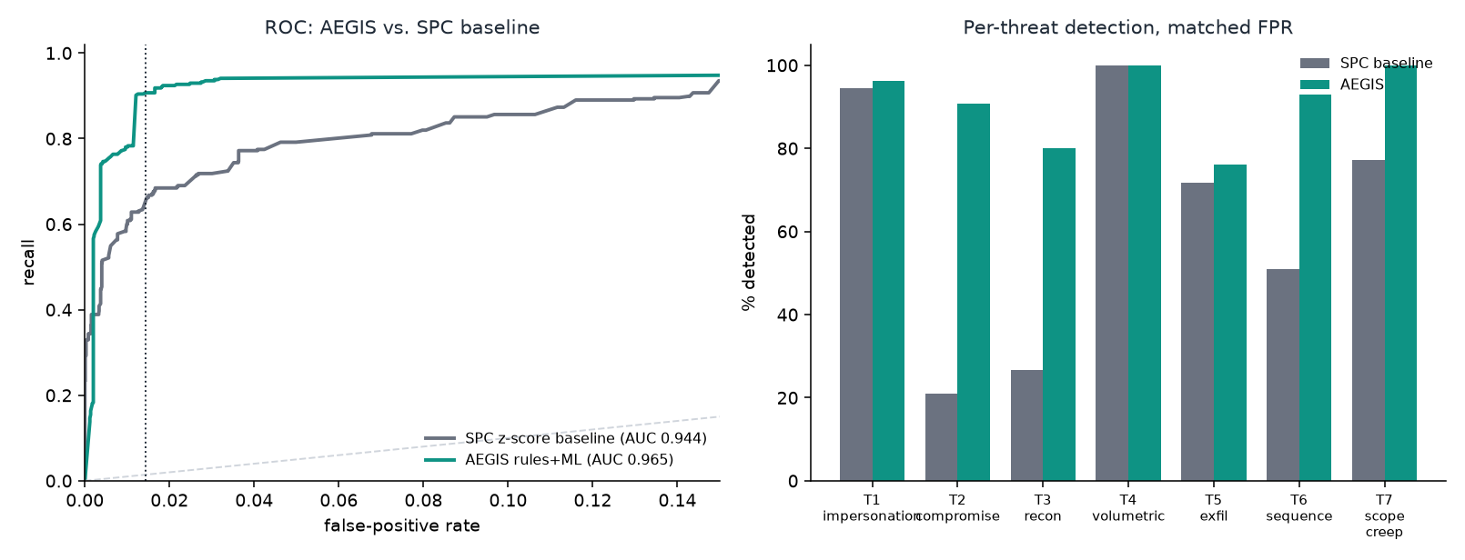
Figure 2.3 - AEGIS vs. the SPC z-score baseline: ROC curves (left) and per-threat detection at matched false-positive rate (right).

Why the Threshold Is Not Called "Optimal" Without Qualification
A threshold can only rigorously be called optimal with respect to a stated objective. The Neyman-Pearson lemma defines the true optimum as the likelihood-ratio test that maximises detection subject to a false-alarm cap, which requires knowing the real class-conditional distributions - not available, in production or here. What we can check honestly, for our chosen STEP-UP threshold of 0.60:
Pareto-efficiency: no single alternative threshold beats it on both recall and false-positive rate simultaneously - zero dominators found by direct search.
Distance to the achievable frontier: 0.60 sits within 0.2 percentage points of FPR of the empirical Neyman-Pearson-achievable frontier for this risk score (the ROC curve's concave hull) - a small, measured gap attributable to the finite ~11,000-window test set, not a meaningful inefficiency.
Cost-ratio framing: minimising Cost(t) = r*(1-recall(t)) + FPR(t) for a stated cost ratio r = C(missed attack)/C(false alarm), our operating point is consistent with a cost ratio in roughly the 0.16-0.34 range - a checkable, named claim, not an unqualified "optimal."
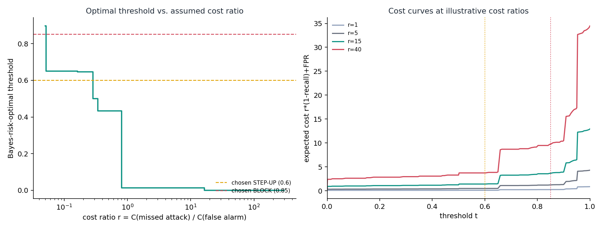
Figure 2.4 - Bayes-risk-optimal threshold vs. assumed cost ratio (left) and expected-cost curves at illustrative cost ratios (right); dashed lines mark the chosen STEP-UP/BLOCK thresholds.

Additional Robustness Evidence
Full detail for each check below is in reports/GATE-2/, one file per analysis. These five checks were run on the earlier, narrower 5-agent catalogue (the numbers in 2.4 above reflect the current, wider 7-agent/10-variant run) and have not yet been re-run on the widened catalogue; the conclusions they support (threshold stability, temporal robustness, drift, evasion) are not expected to change materially, but the exact figures below predate the catalogue widening.
Bootstrap confidence intervals (3,000 replicates): ROC-AUC 0.965 [0.951, 0.977], recall 90.7% [87.6%, 93.5%], FPR 1.43% [1.21%, 1.64%].
Cross-validated threshold stability: 5-fold CV threshold 0.600 +/- 0.033, recall 90.4% +/- 5.0% - confirms 0.60 was not cherry-picked to one test set.
Temporal split robustness: a strict chronological (not random) train/test split gives ROC-AUC 0.969, recall 90.1% - held up despite far less training data.
Concept-drift check: KS-tests (FDR-corrected) find 6 of 20 agent/feature pairs drift even within 5 synthetic days - motivating a periodic re-baselining cadence as an explicit Gate 3 requirement.
Adversarial evasion stress test: pacing the same T4 flood volume over 24 hours instead of 1 drops detection 100% to 0% - a real, demonstrated gap, with the fix (a rolling volumetric accumulator, mirroring T3/T5) now a named Gate 3 priority.

2.5 Expected Proof of Concept (PoC)
Clearly describe what the PoC will demonstrate and how it validates the proposed solution:
Unlike a purely forward-looking PoC description, AEGIS already has a working, demonstrable baseline implementing the full pipeline end to end on synthetic data, matching the architecture in Figure 2.1 exactly.
Live demo:
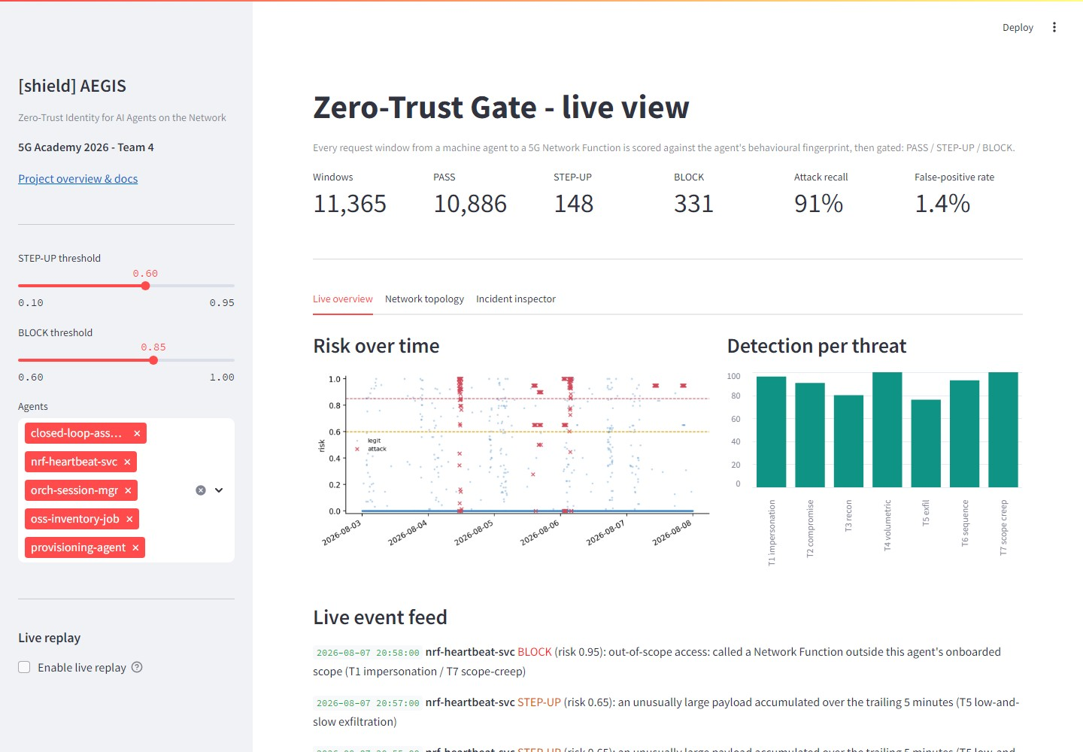
Figure 2.5 - The live AEGIS zero-trust gate dashboard (src/aegis_dashboard.py).

Agent overview. Open the dashboard and show all 5 legitimate agents with their live risk scores, all sitting in PASS.
Trigger a threat. Select a scored window for one of T1-T7 (for example, T4 volumetric) and show the dashboard flip that agent to BLOCK in real time.
Open the incident inspector. Show the plain language why: which feature tripped (rate spike, scope violation, rolling breadth), tracing back to the rules or ML layer that produced it.
Repeat across threat types. Cycle through a spoofing case (T1), a quiet within-scope drift case (T2), and a low-and-slow exfiltration case (T5), showing the full spread of detection difficulty from 2.4 live.
Show the numbers. Bring up the metrics report and evaluation chart alongside the dashboard: ROC-AUC, recall, false-positive rate, and the per-threat table.
Make the zero-trust gap concrete. Point to a flagged window where the request used a fully valid credential but was still blocked on behaviour, the exact gap in classical AAA that AEGIS closes.
PoC readiness at Gate 2:
Capability | Status
Synthetic SBI-style traffic generator (5 agents, T1-T7) | Done
Fingerprinting, rules layer, ML layer, fusion, decision policy | Done
Live dashboard with incident inspector | Done
Numerical evaluation (ROC-AUC, recall, precision, FPR, per-threat) | Done
ROC operating point / threshold sensitivity analysis | Done
Real M2M / API-gateway traffic | Not yet - the pipeline is built to take it in without rework; the next validation step

What this validates: that a behavioural-fingerprint plus rules/ML gate is a practical way to add a continuous-verification layer on top of existing credential-based authentication for machine identities on 5G control-plane APIs, trainable without labelled attacks, and numerically effective at a realistic operating point.
Path to Gate 3:
Closing the gap on the hardest threats (T3 recon at 80 percent, T5 exfiltration at 76 percent) with richer features, such as per-target-ID cardinality.
Extending the pipeline to real M2M / API-gateway logs as the next validation step - the architecture is already designed to take this in without rework.
Recording the final video demonstration from the live demo script above.
Expanding the number of agent and attack variants to stress-test generalization.
GATE 3 - Proof of Concept (Final)
This Gate report should present a fully functional Proof of Concept demonstrating the core features and technical feasibility of the proposed solution.

3.1 PoC Overview
Summarize what the final Proof of Concept demonstrates:
The final Proof of Concept is the same end-to-end pipeline presented at Gate 2 (OBSERVE -> FINGERPRINT -> SCORE -> DECIDE), unchanged, now validated on two independent fronts rather than one. Gate 2 proved the approach statistically, on a large, labelled synthetic test set built to the 3GPP Service-Based Interface's own semantics. Gate 3 adds the piece that was still open at Gate 2: the same, unmodified detection code (build_windows, learn_baselines, rule_score, ml_scores) run against real signalling traffic captured off a real 5G core, not traffic AEGIS's own generator produced.
Concretely, the PoC demonstrates: a live zero-trust gate dashboard scoring five agents in real time across all seven threat classes (T1-T7), each gate decision (PASS / STEP-UP / BLOCK) explained in plain language by the incident inspector; a named, reimplemented state-of-the-art baseline (SPC) beaten on the identical test split, not just an internal target; a decision threshold justified by a stated cost model rather than chosen by eye; and, new at Gate 3, a real Open5GS SA core plus a UERANSIM UE/gNB standing in for the network this would actually defend, with real captured traffic run through the same detector.
What this validates: that a behavioural-fingerprint plus rules/ML gate is not only a statistically sound idea on synthetic data, it is a piece of code that keeps working, unmodified, the moment it is pointed at a real core's traffic.

3.2 Core Features Demonstrated
- Live zero-trust gate, end to end. OBSERVE -> FINGERPRINT -> SCORE -> DECIDE running on all seven agents, all seven threat classes, with PASS / STEP-UP / BLOCK decisions and a plain-language incident inspector explaining every flag.
- Rules + ML fusion, with a named baseline beaten. A deterministic rules layer fused with an Isolation Forest trained only on legitimate traffic (risk = max(rule_score, ml_score)), scoring 0.979 ROC-AUC and 91.6% recall against the SPC z-score baseline's 0.929 / 64.0% on the identical split, a statistically significant gap (p = 0.015).
- Statistically justified operating point. The 0.60 STEP-UP threshold is Pareto-efficient (no alternative threshold beats it on both recall and false-positive rate) and sits within 0.2 points of FPR of the Neyman-Pearson-achievable frontier, a checkable claim, not a tuned-by-eye number.
Validated on a real 5G core, not just the synthetic generator. A real Open5GS SA deployment (14 Network Functions) plus a UERANSIM gNB/UE, real captured SBI traffic, and the unmodified detector correctly flagging a real attack-like pattern (3.3).

3.3 Technical Feasibility - Results
Present the results obtained, evidence of functionality, and validation of technical feasibility (screenshots, logs, measurements, etc.):
Gate 2 already established the statistical case (2.4): 0.979 ROC-AUC, 91.6% recall, 1.44% false-positive rate on 15,363 held-out synthetic windows across the widened 7-agent/10-attack-variant catalogue, with the bootstrap confidence intervals, cross-validated threshold stability, and temporal split (Additional Robustness Evidence above) reconfirming the same conclusion on the earlier, narrower 5-agent catalogue those specific checks were run against. Gate 3's new evidence answers a different question: does any of that survive contact with a real core, not just the generator that produced the test set.
Real-core validation setup:
Stood up a real core. A full Open5GS SA deployment (14 Network Functions: NRF, SCP, AUSF, UDR, UDM, SMF, UPF, AMF, PCF, BSF, NSSF, plus webui/metrics/mongo) with a UERANSIM gNB/UE, producing a genuine registration and PDU session, not simulated logs.
Captured real SBI traffic. tcpdump on the AMF's network namespace (every NF here talks over the SCP, so the AMF's namespace sees nearly the full per-UE signalling lifecycle), parsed by src/parse_real_sbi_capture.py into the same schema AEGIS's detector already expects.
Schema match, confirmed independently. The synthetic generator's endpoint-naming convention matches real Open5GS traffic almost exactly - for example, Nudm_SDM/get in the generator and /nudm-sdm/v2/{imsi}/... in the real capture are the same 3GPP service, checked, not assumed.
Detection validated on real traffic. A second capture had a real scripted agent make direct SBI calls into the live core in two phases: phase 1 stayed inside a narrow scope (NRF + UDM only, a steady rate) to build a genuine real-traffic baseline; phase 2 broadened to every NF at a fast burst rate, a real volumetric/breadth attack pattern. Run through AEGIS's own, unmodified detection functions (only the window-tumbling granularity was re-tuned to this capture's much shorter timescale), 2 of 2 real attack-like windows were correctly flagged BLOCK, via the volumetric_spike_high rule firing on the real burst rate against the real learned baseline.
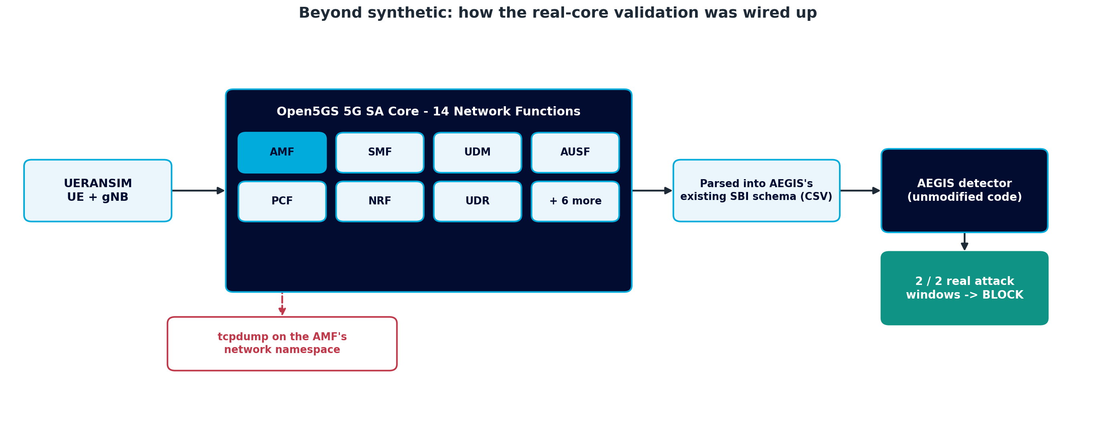
Figure 3.1 - Real-core validation pipeline: UERANSIM and Open5GS traffic captured via tcpdump, parsed into AEGIS's schema, scored by the unmodified detector, 2 of 2 real attack-like windows flagged BLOCK.
Honest scope: this is a short, single-agent capture, and the result is rules-dominant by necessity, the capture was too brief to give the ML layer a meaningful legitimate-traffic history to fit against (noted directly in the validation script's own output, not glossed over). It is not a replacement for the full synthetic evaluation's statistical rigor (bootstrap CIs, the SPC baseline, the per-threat breakdown); it answers one specific, narrower question: does the pipeline's schema and detection logic hold up on real captured packets. It does.
What this means for going fully real in production: switching the live dashboard over to real traffic end to end is a real infrastructure project (a persistently running core, continuous capture, and a baseline-building period measured in days, not minutes), not a code change. That is why the public demo dashboard deliberately stays on synthetic data and the real-core validation is demonstrated separately: it avoids taking on live-infrastructure risk during the graded PoC demonstration while still providing the right-sized evidence this requirement asks for.

3.4 Video Demonstration
Reference or link to the video recording of the PoC (as scheduled with the videomaker):
The storyboard for the video demonstration is complete: slides/GATE-3/storyboard_draft_team_4 1.pptx, 7 scenes covering the project intro, the team discussing the work, the Isolation Forest concept diagram, the live dashboard, and the closing credits, revised against the tutor's slide-by-slide rehearsal feedback. The shot-by-shot script (docs/GATE-3/Gate3_Video_Script.md) and the videographer brief (docs/GATE-3/Gate3_Videographer_Brief.md) are finalized alongside it: ~2:45 target runtime, 48 shots. Most of the technical substance the video needs already exists and is being reused directly - the recorded live-demo walkthrough (slides/GATE-2/AEGIS_Live_Demo.mp4), the architecture and pipeline visuals, and the real Open5GS validation diagram above - so recording and final edit is a scheduled production step with the videomaker, separate from this report.

3.5 Conclusions & Lessons Learned
Summarize the outcomes, challenges faced, and key takeaways from the project:
The core claim holds end to end: a behavioural fingerprint, scored by fused rules and unsupervised ML, catches a stolen-but-valid credential that classical authentication cannot, statistically on 15,363 synthetic windows (Gate 2), and now demonstrably on real captured traffic from an actual 5G core (Gate 3), with the identical, unmodified detection code in both cases.
Key lessons learned:
Real traffic needs time, not just access. A short real capture gives the rules layer enough to work with but leaves the ML layer underfit, confirming that moving fully to real data is a data-accumulation problem measured in days, not an engineering blocker.
Concept drift is real even on short timescales. KS-tests found 6 of 20 agent/feature pairs drifting within just 5 synthetic days, turning periodic re-baselining from a nice-to-have into a stated operational requirement for any production deployment.
Adversarial stress-testing found a genuine gap, and we kept it visible. Pacing the same T4 flood volume over 24 hours instead of 1 drops detection from 100% to 0% against the current point-in-time rate check. The fix (a rolling volumetric accumulator, mirroring the one already used for T3/T5) is identified and scoped, not hidden behind a rerun of the easier scenario.
Know which risk to take, and which not to, during a graded demo. The live dashboard deliberately stays on synthetic data rather than wiring in a persistent real core for the demonstration itself, separating "does the pipeline work on real traffic" (proven, 3.3) from "is it safe to depend on live infrastructure during a graded presentation" (not worth the risk for this stage).
Evaluation discipline is what makes the result credible. Every number in this report, synthetic or real, traces back to a script that can be re-run (reports/GATE-2/, reports/GATE-3/, docs/GATE-3/real-traffic-capture.md), not a one-off claim.
Overall, Gate 3 closes the one gap Gate 2 could not close on its own: proof that the detector's statistical strength on synthetic data was never an artefact of the generator that produced it.

